**Practical project – Arduino Alcohol Sensor – Documentation**

**Students**: Vlad Lusca, Stefan Popa

**Faculty**: Automation and Computers

**Group**: 30312

1. **Introduction**

An alcohol sensor for Arduino is a versatile and cost-effective device that allows users to detect the presence and concentration of alcohol (ethanol) in the surrounding environment. These sensors typically use semiconductor technology, where the sensor's material reacts with ethanol molecules in the air, causing a change in its electrical resistance. This resistance change can then be measured by an Arduino board, which interprets the data and outputs a corresponding alcohol concentration level. Alcohol sensors are commonly used in breathalyzers, where they measure the alcohol content in a person's breath, but their applications extend to safety systems, such as detecting alcohol in a vehicle's cabin or monitoring alcohol levels in industrial environments. Through the Arduino platform, these sensors can be easily integrated with other modules like displays, buzzers, or alarms to create real-time alcohol detection systems. The simplicity of interfacing an alcohol sensor with an Arduino makes it an excellent choice for both hobbyists and professionals looking to implement alcohol detection in their projects.

1. **Components**

* Breadboard
* Arduino Uno board
* LED screen
* Piezo
* Red LED
* Green LED
* 2 100 ohms resistors
* Potentiometer
* MQ3 sensor

1. **The scheme**

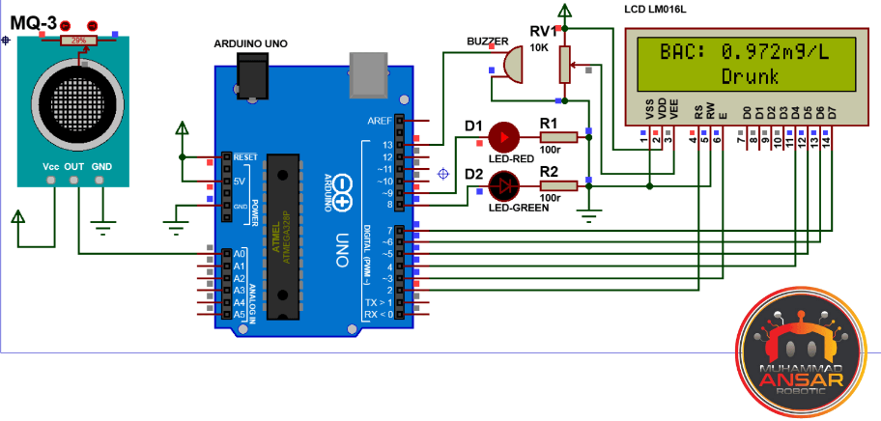

1. **Data sheet for MQ3 sensor**

* **https://www.google.com/url?sa=i&url=https%3A%2F%2Fwww.mouser.com%2Fdatasheet%2F2%2F272%2Fmq3-alcohol-sensor-datasheet-1864348.pdf&psig=AOvVaw34RTtfW0GwmSpJatD7NbhL&ust=1737059553950000&source=images&cd=vfe&opi=89978449&ved=0CBgQ3YkBahcKEwiYw8qeyfiKAxUAAAAAHQAAAAAQBA**

1. **The prototype**

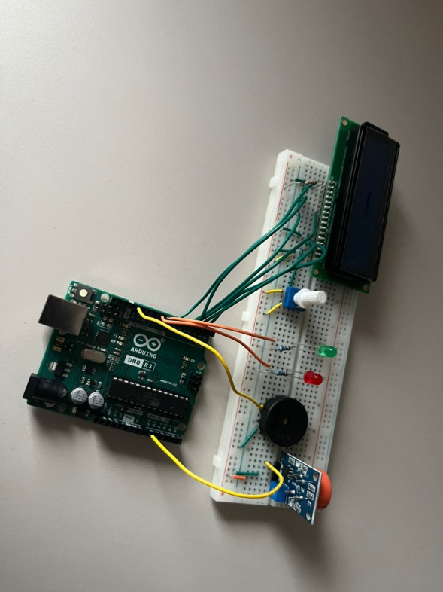

1. **Arduino code**

**THE SET UP:**

#include <LiquidCrystal.h> // Include LCD library for display

LiquidCrystal lcd(2, 3, 4, 5, 6, 7); // Initialize the LCD with Arduino pins

#define sensor_pin A0 // Analog pin for alcohol sensor input

#define G_led 8 // Green LED pin

#define R_led 9 // Red LED pin

#define buzzer 13 // Buzzer pin

#define button_pin 10 // Button pin to start recording

float adcValue = 0, val = 0, mgL = 0; // Variables for sensor reading and calculations

bool displayResult = false; // Flag to hold the result display state

float avgMgL = 0; // Variable to store average concentration

void setup() {

pinMode(sensor_pin, INPUT); // Set sensor pin as input

pinMode(R_led, OUTPUT); // Set Red LED as output

pinMode(G_led, OUTPUT); // Set Green LED as output

pinMode(buzzer, OUTPUT); // Set Buzzer as output

pinMode(button_pin, INPUT_PULLUP); // Set Button pin with internal pull-up resistor

lcd.begin(16, 2); // Initialize the LCD with 16 columns and 2 rows

lcd.clear(); // Clear the LCD display

lcd.setCursor(0, 0);

lcd.print(" Arduino + "); // Display welcome message

lcd.setCursor(0, 1);

lcd.print("Alcohol Etilotest");

delay(2000); // Delay for 2 seconds to display the message

lcd.clear(); // Clear the LCD

}

**THE LOOP FUNCTION:**

void loop() {

if (digitalRead(button_pin) == LOW) { // Check if the button is pressed

recordAverage(); // Start recording average sensor values

}

if (displayResult) { // Display the result until button pressed again

lcd.setCursor(0, 0);

lcd.print("Avg: ");

lcd.print(avgMgL, 3);

lcd.print("mg/L ");

lcd.setCursor(0, 1);

if (avgMgL > 0.8) {

lcd.print("Cant drive Drunk");

digitalWrite(buzzer, HIGH);

digitalWrite(G_led, LOW);

digitalWrite(R_led, HIGH);

} else {

lcd.print(" Can drive ");

digitalWrite(G_led, HIGH);

digitalWrite(R_led, LOW);

digitalWrite(buzzer, LOW);

}

return;

}

adcValue = 0;

for (int i = 0; i < 10; i++) { // Read sensor value 10 times for averaging

adcValue += analogRead(sensor_pin);

delay(10); // Short delay between readings

}

val = (adcValue / 10) * (5.0 / 1024.0) - 1.65; // Convert ADC value to voltage

mgL = 0.67 * val; // Convert voltage to mg/L alcohol concentration

lcd.setCursor(0, 0);

lcd.print(" Val: ");

lcd.print(mgL, 3); // Display alcohol concentration

lcd.print("mg/L ");

lcd.setCursor(0, 1);

if (mgL > 0.8) { // If alcohol level exceeds the limit

lcd.print("Cant drive Drunk"); // Warning message

digitalWrite(buzzer, HIGH); // Turn on the buzzer

digitalWrite(G_led, LOW); // Turn off Green LED

digitalWrite(R_led, HIGH); // Turn on Red LED

delay(300); // Delay to allow buzzer sound

} else {

lcd.print(" Can drive "); // Safe driving message

digitalWrite(G_led, HIGH); // Turn on Green LED

digitalWrite(R_led, LOW); // Turn off Red LED

}

digitalWrite(buzzer, LOW); // Turn off the buzzer

delay(100); // Short delay before next loop

}

void recordAverage() {

lcd.clear();

for (int i = 3; i > 0; i--) { // Countdown from 3 to 1

lcd.setCursor(0, 0);

lcd.print("Timer starts in ");

lcd.print(i);

delay(1000);

}

lcd.clear();

lcd.setCursor(0, 0);

lcd.print("Recording..."); // Display recording status

float sumValues = 0; // Sum of sensor readings

int sampleCount = 0; // Counter for the number of samples

unsigned long startTime = millis(); // Record the start time

while (millis() - startTime < 10000) { // Record for 10 seconds

sumValues += analogRead(sensor_pin); // Sum sensor readings

sampleCount++; // Increment sample counter

delay(10); // Delay between readings

}

float avgValue = (sumValues / sampleCount) * (5.0 / 1024.0) - 1.65; // Average voltage

avgMgL = 0.67 * avgValue; // Convert to mg/L alcohol concentration

displayResult = true; // Enable result display until button pressed again

}

1. **Bibliography**

* https://lastminuteengineers.com/mq3-alcohol-sensor-arduino-tutorial/
* https://www.youtube.com/watch?v=0Q9XhZ_gY_M
* https://marobotic.com/2023/10/30/arduino-and-mq-3-sensor-based-alcohol-detector/
* https://www.sparkfun.com/datasheets/Sensors/MQ-3.pdf
* https://www.uio.no/studier/emner/matnat/ifi/IN1060/v21/arduino/arduino-projects-book.pdf